Stability Analysis at plant Input and Output
Chris Bonney (March 2021)
Program Start 1
Plant Data 1
Dynamics without actuator 2
Dynamics with Actuator 2
Design RSLQR controller 2
print analysis 5
small gain thrm 13
list controller matrices 13

Program Start
clear all
close all
clc
format short e
% add my set of functions to path
addpath('functions')
RSLQR.name = 'RSLQR';

Plant Data
Controller Constants
Ka=-0.0015;
Kq=-0.32;
az=2;
aq=6;
% Dynamics Constants
V=886.78;
Za=-1.3046*V;
Zd=-0.2142*V;
Ma=47.7109;
Md=-104.8346;
% Actuator Constants
% omega = sqrt(12769);
% zeta = 0.6;
omega = 2.*pi*11;
zeta = sqrt(1/2);

Dynamics without actuator
Ap = [Za/V 1 ;
Ma 0 ];
Bp = [Zd/V ;
Md ];
Cp = [Za 0 ;
0 1 ];
Dp = [Zd ;
0 ];
RSLQR.DesignPlant = ss(Ap,Bp,Cp,Dp);
% Size of the plant model
[nx,~]=size(Ap);

Dynamics with Actuator
A_actuator = [0 1; -omega^2 -2*zeta*omega];
B_actuator = [0; omega^2];
Plant.Ap = [ Ap Bp zeros(2,1);
zeros(2,2) A_actuator];
Plant.Bp = [zeros(2,1); B_actuator];
Plant.Cp = [Za 0 Zd 0;
eye(4)];
% Plant.Cp = [Za 0 Zd 0;
% 1 0 0 0;
% 0 1 0 0];
Plant.Dp = 0*(Plant.Cp*Plant.Bp);
Ap = Plant.Ap;
Bp = Plant.Bp;
Cp = Plant.Cp;
Dp = Plant.Dp;
RSLQR.AnalysisPlant = ss(Ap,Bp,Cp,Dp);

Design RSLQR controller
paramaters: controller model, cmd state, feedback states, analysis model, ... vector of values for qq, and the system structure
RSLQR = design_lqr(RSLQR.DesignPlant,1,[2,3],RSLQR.AnalysisPlant,logspace(-6,-3,50),RSLQR);
% AZ TIME HISTORIES OF LQR CONTROLLERS
figure('Name','LQR Time Histories')
hold on
for itr = 1:length(RSLQR.Design_data)
plot(RSLQR.t,RSLQR.Design_data(itr).y(:,1))
end
best_plot = plot(RSLQR.t,RSLQR.y(:,1),'r','LineWidth',2);
xlabel('time (sec)');
ylabel('Az (fps2)');
legend(best_plot,'Best RSLQR','Location','best');
title('LQR Time Histories');
rd_min_ii = [RSLQR.Design_data(:).rd_min];
sr_min_ii = [RSLQR.Design_data(:).sr_min];
wc_ii = [RSLQR.Design_data(:).LGCF];
figure('Name','LQR Controllers Min RD, Min SR');
hold on
plot(wc_ii,rd_min_ii,'r','LineWidth',2)
plot(wc_ii,sr_min_ii,'b','LineWidth',2)
plot(RSLQR.LGCF,RSLQR.rd_min,'ko','MarkerSize',10,'LineWidth',2)
grid on
xlabel('wc (rps)');
ylabel('min RD, min SR');
legend(['Min RD SV'],['Min SR SV'],['Cross Point']);
figure('Name','LQR design LGCFs')
semilogy(wc_ii,RSLQR.qq,'LineWidth',2);
hold on
semilogy(RSLQR.LGCF,RSLQR.best_qq,'ko','MarkerSize',10,'LineWidth',2)
grid on
xlabel('wc (rps)');
ylabel('qq');
title('LQR design LGCFs');
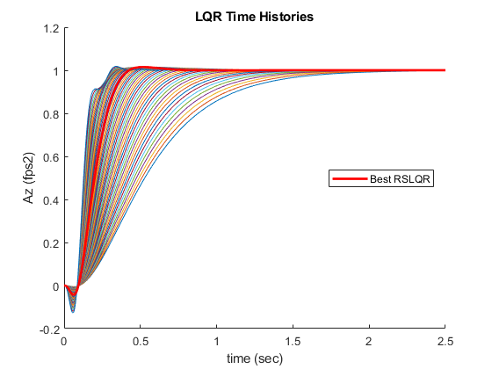
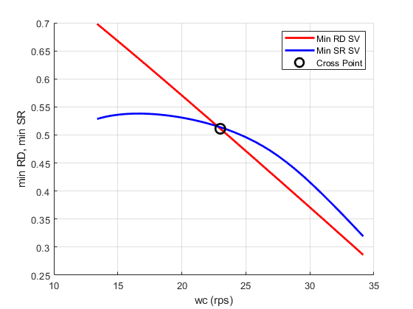
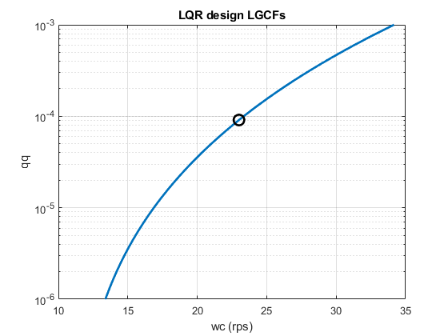

print analysis
paramaters: any number of plant+controller structures makes plots and prints controller + system properties
print_analysis(RSLQR);
RSLQR Controller Model
[ Ac Bc1 Bc1 ]
HH =
[ 0, 1.0, 0, 0, 0, 0, -1.0]
[ Cc Dc1 Dc2 ]
HH =
[ -0.00954, 0, 2.63, 0.238, 0, 0, 0]
RSLQR Closed Loop Eigenvectors
V =
Columns 1 through 2
1.0786e-03 - 5.3831e-04i 1.0786e-03 + 5.3831e-04i
-8.6197e-03 + 5.3792e-02i -8.6197e-03 - 5.3792e-02i
1.4975e-02 + 1.7154e-02i 1.4975e-02 - 1.7154e-02i
-9.9198e-01 + 0.0000e+00i -9.9198e-01 + 0.0000e+00i
1.6200e-02 + 1.1055e-01i 1.6200e-02 - 1.1055e-01i
Columns 3 through 4
-9.2478e-03 + 0.0000e+00i 6.3990e-03 - 6.9127e-03i
2.1023e-01 + 0.0000e+00i -1.2874e-03 + 1.0138e-01i
4.2040e-02 + 0.0000e+00i 9.5275e-03 + 5.9743e-03i
-9.6959e-01 + 0.0000e+00i -1.3059e-01 + 1.0489e-02i
-1.1764e-01 + 0.0000e+00i 9.8607e-01 + 0.0000e+00i
Column 5
6.3990e-03 + 6.9127e-03i
-1.2874e-03 - 1.0138e-01i
9.5275e-03 - 5.9743e-03i
-1.3059e-01 - 1.0489e-02i
9.8607e-01 + 0.0000e+00i
RSLQR Closed Loop Eigenvalues
ans =
-2.8650e+01 + 3.2818e+01i
-2.8650e+01 - 3.2818e+01i
-2.3063e+01 + 0.0000e+00i
-9.3428e+00 + 6.9594e+00i
-9.3428e+00 - 6.9594e+00i
RSLQR Classical Margins
GainMargin: [3.4428e-01 3.1892e+00]
GMFrequency: [7.6743e+00 6.0081e+01]
PhaseMargin: 3.2804e+01
PMFrequency: 2.3002e+01
DelayMargin: 2.4891e-02
DMFrequency: 2.3002e+01
Stable: 1
RSLQR Combined SV Margins
Min SV of RD: min(I+Lu) = 0.51112
Min SV of SR: min(I+Lu) = 0.51384
Singular Value GM = [-6.2645 dB , 6.216 dB]
Singular Value PM = [+/-29.7749 deg]
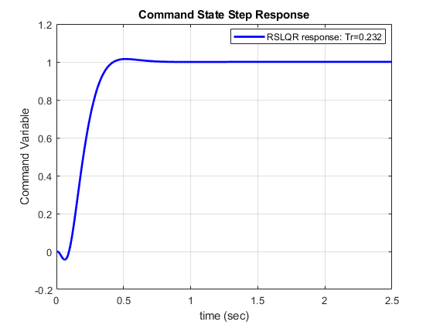
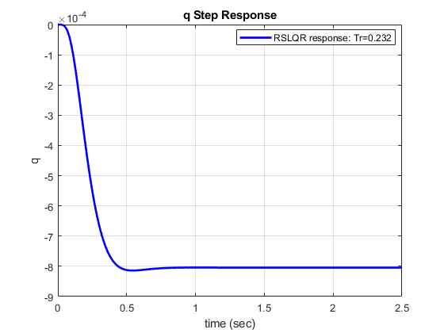
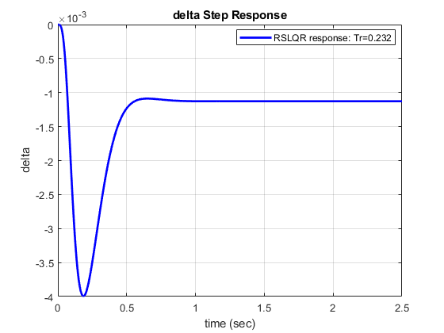
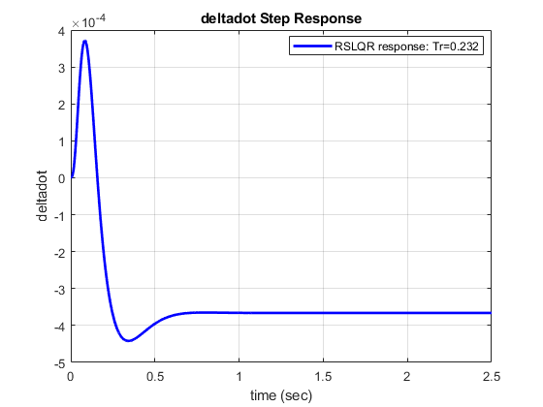
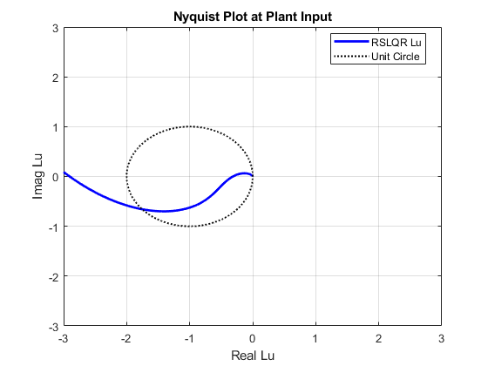
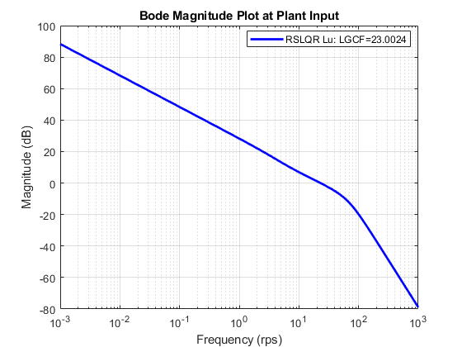
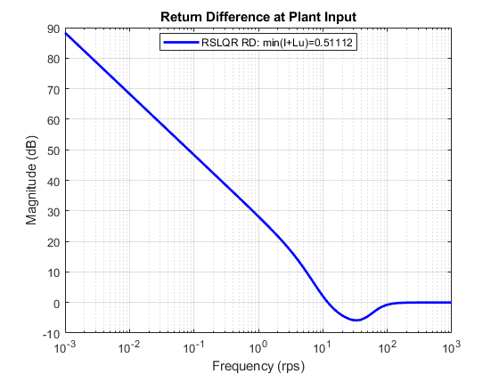
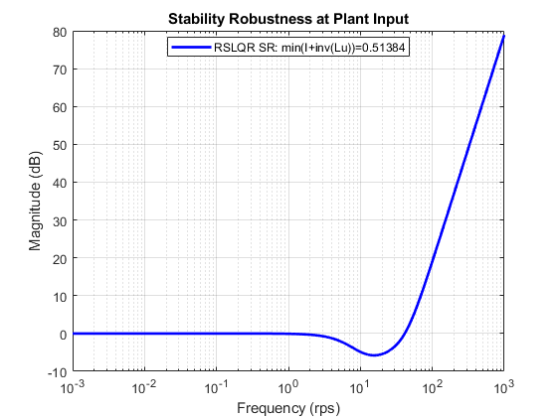
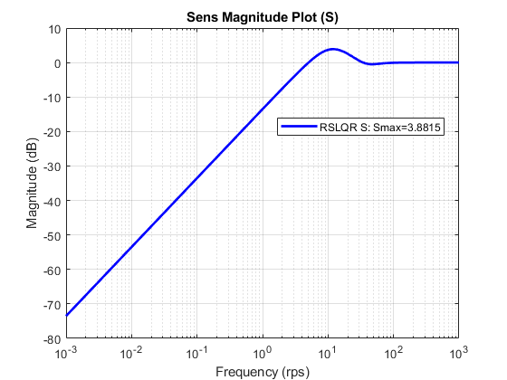
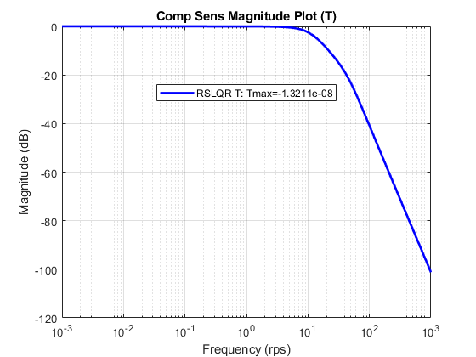
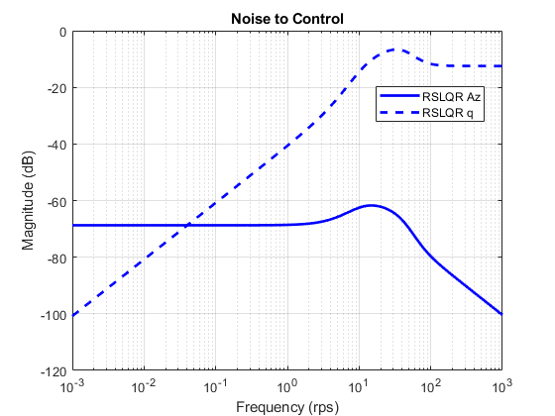
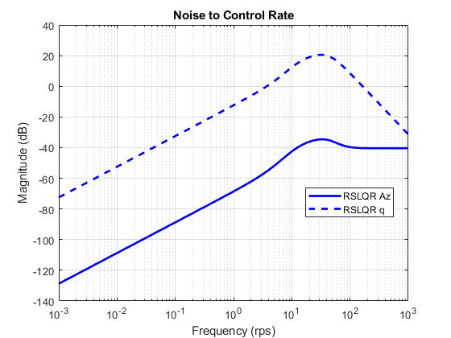

small gain thrm
M = -RSLQR.Lu./(1+RSLQR.Lu);
RSLQR.M = M;
w = RSLQR.w;
figure('Name', 'small gain thrm')
semilogx(w,20*log10(abs(squeeze(1./M))),'k','LineWidth',2)
hold on
delta = omega^2./(omega^2+2*zeta.*omega.*w*1i+(w*1i).^2) - 1;
semilogx(w,20*log10(abs(delta)),'r','LineWidth',2)
legend('sgm(1/M)','\Delta = actuator - 1','Location','best')
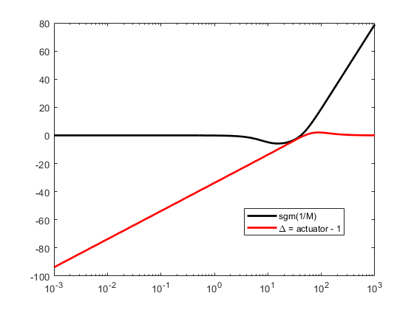

list controller matrices
Q = RSLQR.Q
R = RSLQR.R
Aw = RSLQR.Aw
Bw = RSLQR.Bw
Ac = RSLQR.Controller.Ac
Bc1 = RSLQR.Controller.Bc1
Bc2 = RSLQR.Controller.Bc2
Cc = RSLQR.Controller.Cc
Dc1 = RSLQR.Controller.Dc1
Dc2 = RSLQR.Controller.Dc2
Q =
9.1030e-05 0 0
0 0 0
0 0 0
R =
1
Aw =
0 -1.1569e+03 0
0 -1.3046e+00 1.0000e+00
0 4.7711e+01 0
Bw =
-1.8995e+02
-2.1420e-01
-1.0483e+02
Ac =
0
Bc1 =
1 0 0 0 0
Bc2 =
-1
Cc =
-9.5410e-03
Dc1 =
0 2.6270e+00 2.3809e-01 0 0
Dc2 =
0
save('RSLQR_design.mat','RSLQR');
Published with MATLAB® R2020a

